Flags- Angle Exploration
Subject: Mathematics Creator: Alison Kimbley
Strand: Shape and Space Grade: 6
Content (topic)

Exploring Angles
Outcomes  SS6.1 Demonstrate an understanding of angles including:  - Identifying examples classifying angles  - Estimating the measure  - Determining angle measures in degrees  - Drawing angles  - Applying angle relationships in triangles and quadrilaterals | Indicators  SS 6.1a: Observe, and sort by approximate measure, a set of angles relevant to self, family or community.  SS 6.1b: Explore and present First Nations and Métis people, past and present, measure, represent, and use angles in their lifestyles and worldviews  SS 6.1g: Measure angles in different orientations using a protractor.
Lesson Preparation
Equipment/materials:
- Appendix A for each student
Presentation
Development
- Explain to students that flags are an important aspect of identity to the Country or Nation it symbolically represents. The flags of the Indigenous Nations are treated with respect and honour as the colour and symbols on each of the flag represent the Nations struggles, honor and pride.
- Discuss with your students the significance of the City of Regina deciding to fly the Treaty Four Flag in a permanent place over City Hall.
- Have them read the news item and view the videos on the CBC web site.
- The flag images in Appendix A as well as many more can be found on the web pages in the references.
- Have the students examine pictures of the flags and identify and measure a total of 8 angles on the flags by using a protractor. Different angles identified may have the same measure.
- After the students have identified angles on the Indigenous flags, ask the students to create a flag that represents themselves and/or culture while including at least three angle with different measures.
- Have students present their flags and discuss how angles in the flags are relevant to themselves, culture, family or community.
References

http://www.flagshop.com/gallery-aboriginal.php
http://www.tlichohistory.com/tlicho_flag.html
http://www.crwflags.com/fotw/flags/ca_efn.html
http://www.crystalinks.com/crow.html
http://www.cbc.ca/news/canada/saskatchewan/story/2011/10/14/sk-treaty-four-flag-regina-city-hall-111014.html

Appendix A

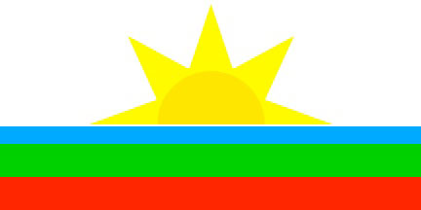

Elsipogtog First Nation is the largest Migmag community in New Brunswick Canada.

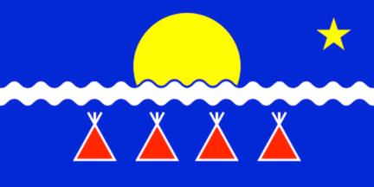

The traditional land of the Tilcho includes a vast area of boreal forests, waterways, and tundra from the northern shores of Great Slave Lake to almost the shores of Northwest Territories of Canada

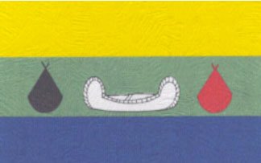

The community of Eabametoong First Nation is situated on the north shore of Eabamet Lake, located 360 kilometers north of Thunder Bay. The Eabametoong have kept their way of life through fishing, hunting and gathering food.



The Métis Flag was first used by Métis resistance fighters in Canada prior to the Battle of Seven Oaks in 1816. The flag is either blue or red with a white infinity symbol superimposed on top. The symbol represents the mixing of the European immigrants and the First Nations peoples, which creates a new and distinct culture, the Métis.

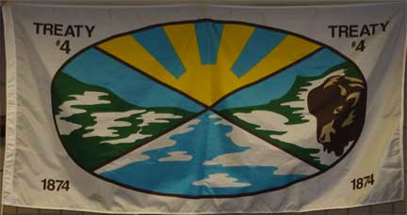

The Treaty 4 flag was envisioned by the late Elder Gordon Oakes whose dream it was for the people of Treaty 4 territory to have their own flag to be raised with the national and provincial flags. Elder Oakes’ son Larry Oakes explained, “The flag represents the spirit of working together with all people on this land.”

