Chektnak- Stick Dice- Line Graphs

Subject: Mathematics Creator: Ashley Pennington
Strand: Statistics and Probability Grade: 6
Content (topic)

Understanding Data Analysis
Outcomes  SP6.1: Extend understanding of data analysis to include:  - Line graphs  - Graphs of discrete data  - Data collection through questionnaires, experiments, databases, and electronic media  - Interpolation and extrapolation. | Indicators  SP 6.1d: Construct a graph (line graph or a graph of discrete data points) to represent data given in a table for a particular situation
Lesson Preparation:
Equipment/materials:
- 4 Sticks of equal length and width. Two sticks have stripes on one side and the other two sticks have crosses on one side. Game sticks can alternately be made with Popsicle sticks. (See Appendix A)
- Activity sheets (Appendix C)
- Scoring table (Appendix B)
Advanced Preparation:
- Have sticks prepared for student’s usage.
- A copy of Appendix C for each student.
- Have the scoring table (Appendix B) displayed on an overhead so that all the students can see it.
- Have the example activity sheet (Appendix D) displayed on an overhead so that all the students can see it.
Presentation
Development
- The game called Chekutnak or Stick Dice is described in the games section of Aboriginal Perspectives. For this lesson we are going to modify the rules slightly.
- The player drops or tosses the four sticks and points are awarded according to the table below.
- Arrange the students in pairs and give each pair a set of 4 sticks and two score sheets. Have each student put his or her name at the top of the score sheet.
- In each pair have the first student toss the sticks 10 times and have the second student record the score on each toss and the running total on the first student's score sheet.
- Have the students reverse roles so that the second student tosses the sticks and the first student records the score and running total on the second student's score sheet.
- Have each student take his or her own scores sheet and construct a line graph of the score. In a different color have each student construct a line graph of the running total. An example is shown in the example score sheet.
- An example of the game can be found in Appendix D.

Appendix A
Game sticks

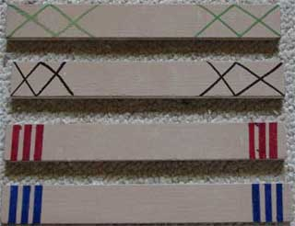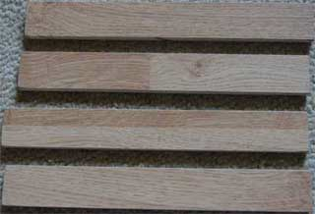

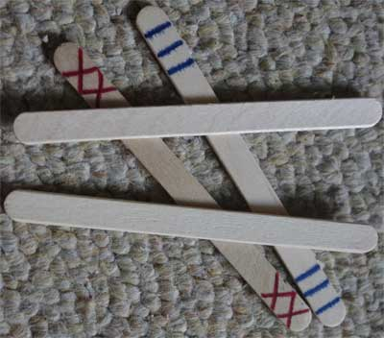

Appendix B
Scoring Table

Roll | Points
All 4 painted sides up | 5
All 4 blank sides up | 4
2 blank & 2 C painted | 3
2 blank & 2 S painted | 2
2 blank, 1 S painted & 1 C painted | 1
any other combination | 0
S=stripes
C= cross
Examples

A 3 point toss

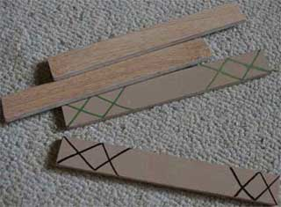

A 2 point toss

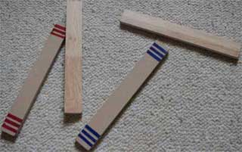

Appendix C
Activity Sheet

Name: ________________________

Score Sheet

Toss Number | 1 | 2 | 3 | 4 | 5 | 6 | 7 | 8 | 9 | 10
Score

Running Total

Score

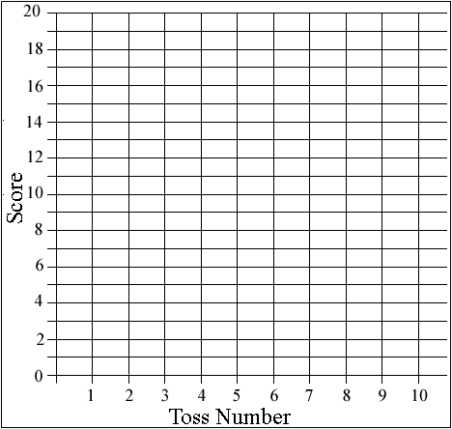

Running Total

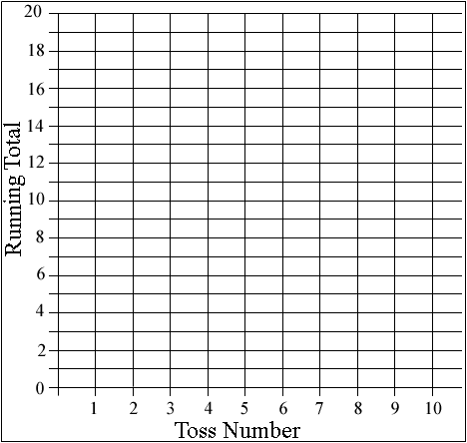

Appendix D
Example Activity Sheet Name: Ashley
Time: Grade:6

Toss Number | 1 | 2 | 3 | 4 | 5 | 6 | 7 | 8 | 9 | 10
Score | 0 | 5 | 3 | 1 | 0 | 0 | 3 | 0 | 2 | 0
Running Total | 0 | 5 | 8 | 9 | 9 | 9 | 12 | 12 | 14 | 14

Score

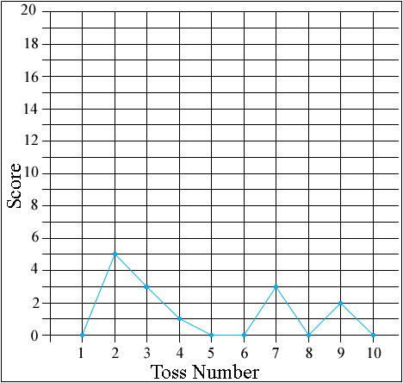

Running Total

